MACH4METAL

metalworking machinery
Transito 21, 6909 DA Babberich, Netherlands
Tel. + 31 (0)316 – 247123
Fax. + 31 (0)316 - 247956
info@mach4metal.com
www.mach4metal.com
Bank No : 66.52.13.883
IBAN : NL33 INGB 0665 2138 83
BIC : INGBNL2A
VAT : NL 815393635B01

CNC Lathe EST TICINO 1300 x 6500 mm

- Make : EST Ticino Italia
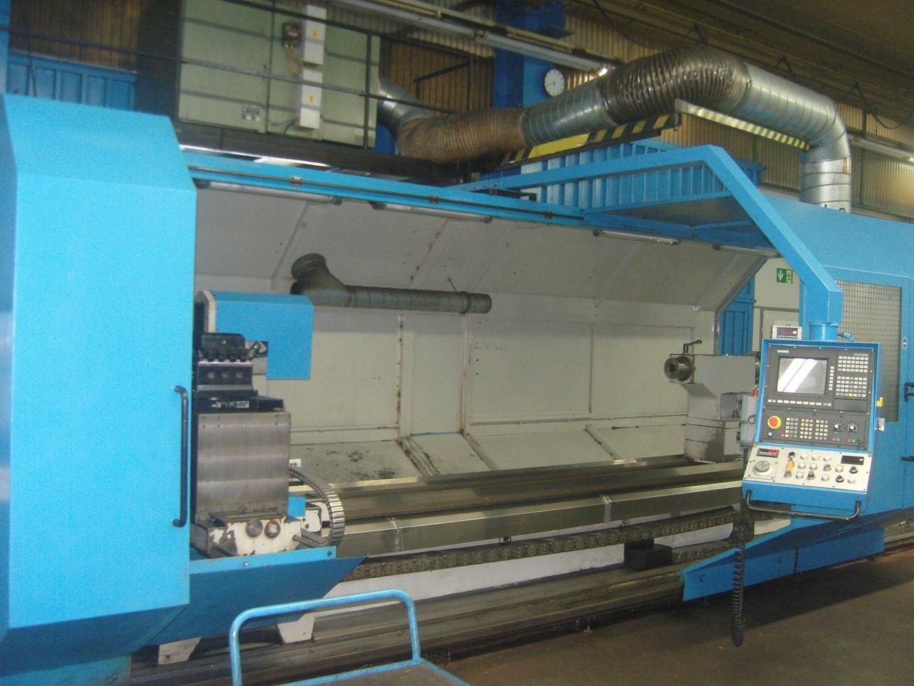
- Type : ET BM CT 650 x 4200
- Age : 1995 – 2015
- Mach. No :

- Swing over bed : 1.300
- Swing over support : 970
- Swing in the gap : 2.000

- Centre distance Ø : 4.500
- Gap length : 2.000
- Centre distance bed open : 6.500
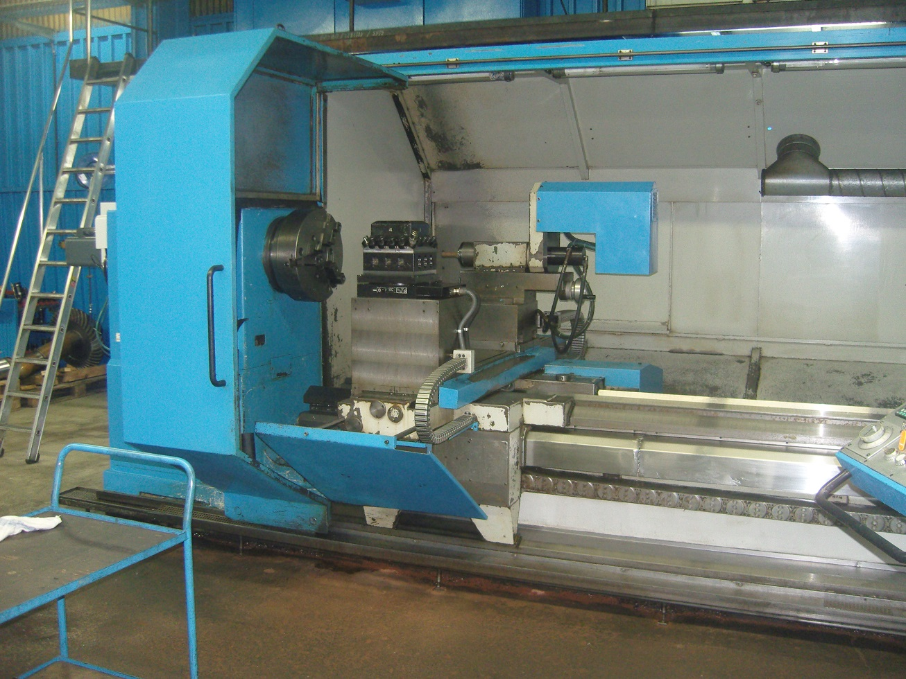

- Torq on chuck Nm : 9.400
- Work load Kg : 7.500

- Spindle bore : 150 ?
- Bed width with double prism : 620
- Bed width with third guide : 800
- Length of the main-slide guides : 960

- Diameter tailstock spindle : 150
- Travel Manuel quill : 400
- Morse taper : Mk-6
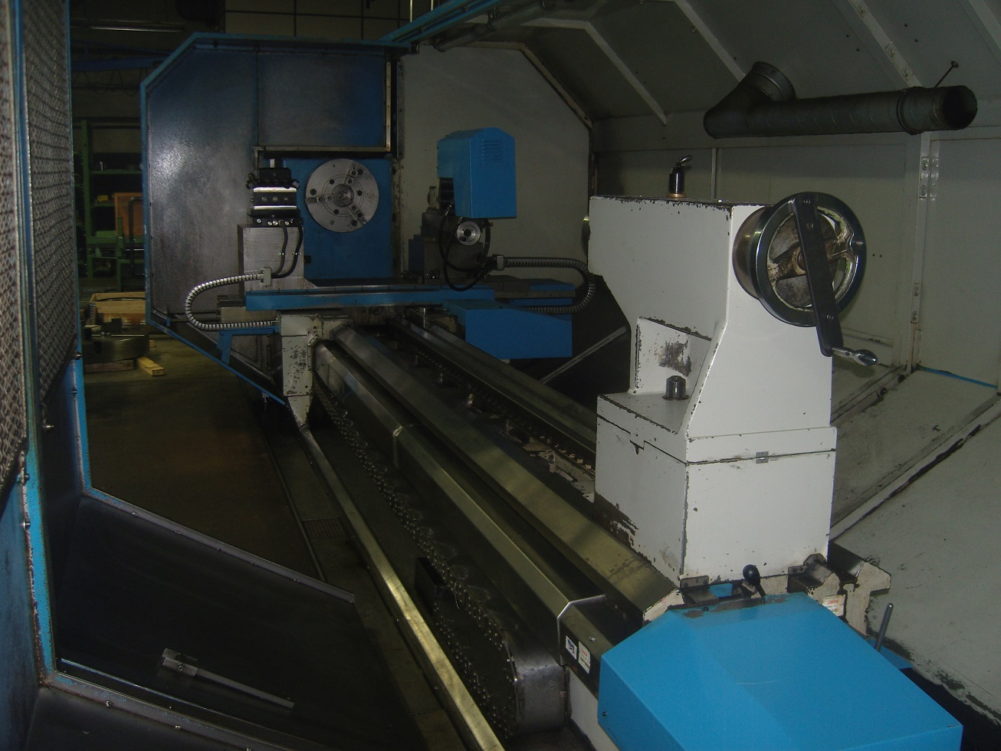

- Motor power Kw : 50
- Rapid movement X + Z mm/min. : 6.000

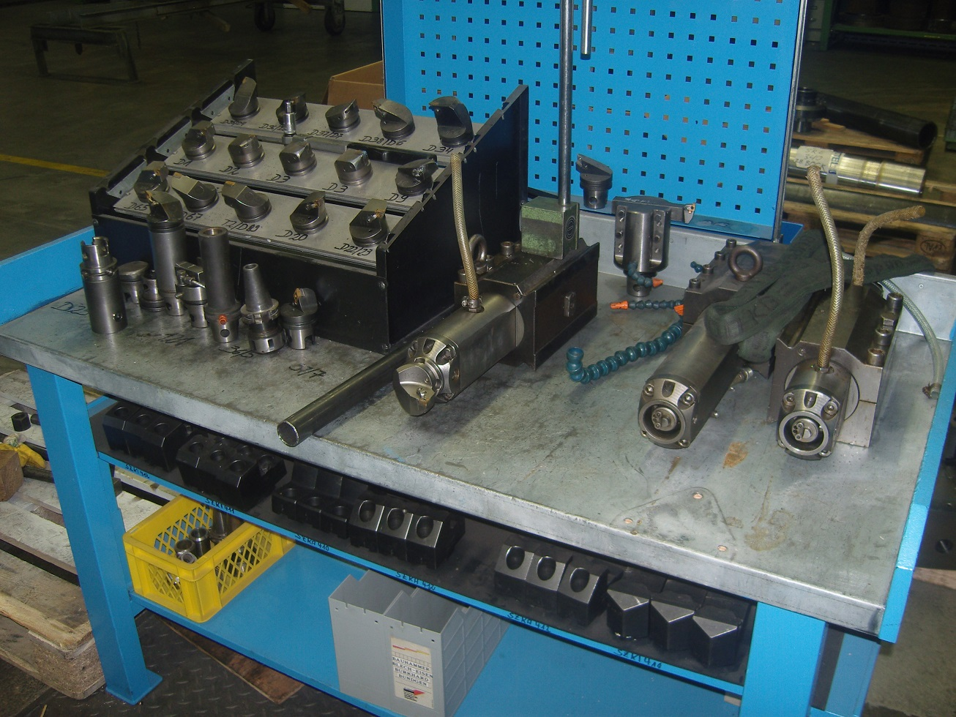

- Speeds Rpm : 900
- Range 1 : 25 - 95
- Range 2 : 90 - 310
- Range 3 : 300 – 900

- Milling attachment over CNC
- Spindle Taper :
- Spindle power :
- Spindle speeds :
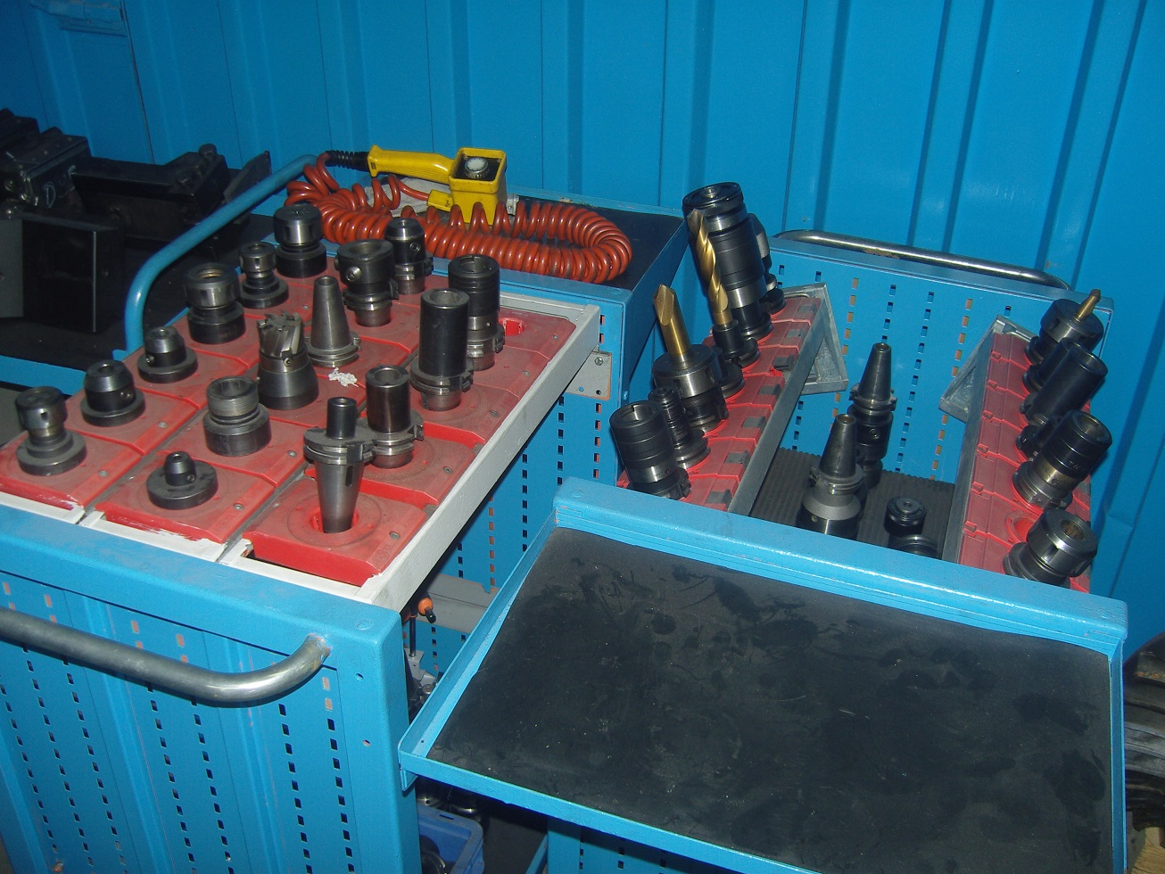
- Sauter revolver 4 positions
- SIEMENS Sinumrik 840C
- Motorized tailstock

- Optional tooling package
- 4 chuck Ø
- Milling tooling
- Turning tools
- Steady rest Ø

- Coolant system
- Central lubrication
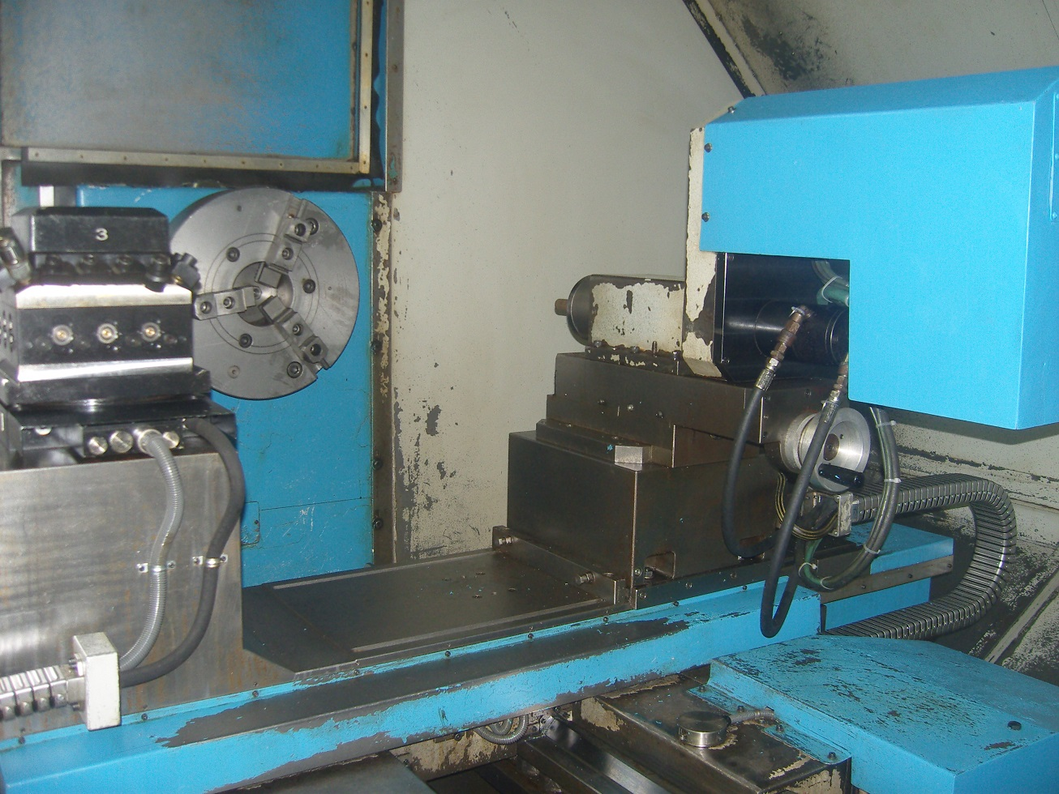

- Dimensions

- Length : 10.000
- Width : 3.000
- Height : 3.600
- Weight : 15.000

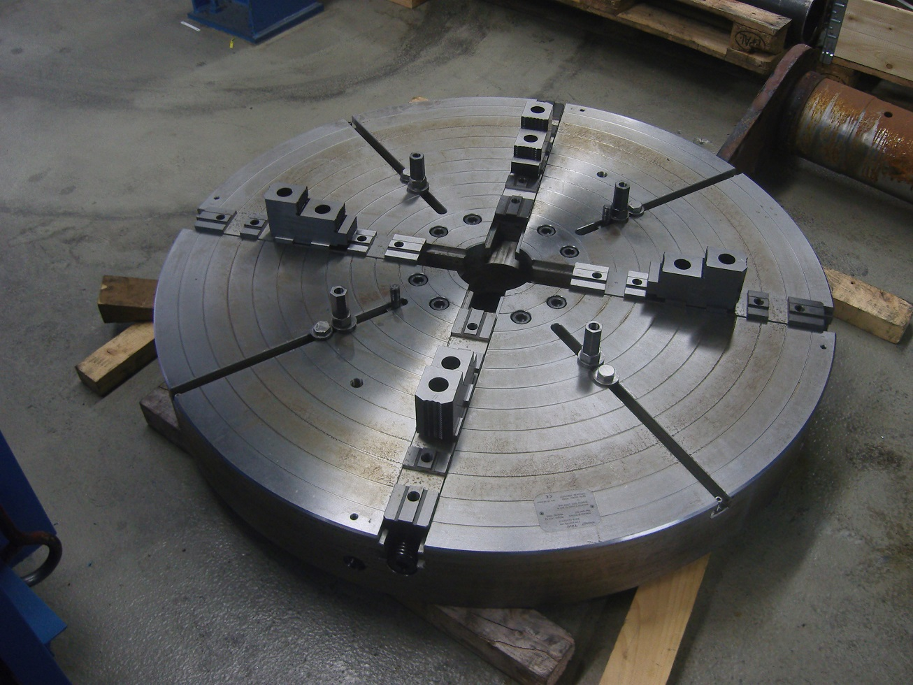

Please Note: The above information has been obtained to the best of our ability and belief from, and from the manufacturers where possible. It is given in good faith, but its accuracy can not be guaranteed. Accordingly, it will not form a representation or constitute contractual terms. We advise you to check any vital details!

